[Become a member](https://medium.com/membership?source=upgrade_membership---nav_full------------------------)

[Sign in](https://medium.com/m/signin?operation=login&redirect=https%3A%2F%2Fmedium.com%2F%40AyunasCode%2Fhow-to-push-large-files-to-github-253d05cc6a09&source=post_page-----253d05cc6a09----------------------)

Get started

How to push large files to GitHub

[](https://medium.com/@AyunasCode?source=post_page-----253d05cc6a09----------------------)

[Ayuna Vogel](https://medium.com/@AyunasCode?source=post_page-----253d05cc6a09----------------------)

Follow

[Mar 31, 2016](https://medium.com/@AyunasCode/how-to-push-large-files-to-github-253d05cc6a09?source=post_page-----253d05cc6a09----------------------) · 4 min read

Ever tried to upload a large file to GitHub? This post is to help you save some valuable time.

Some background: I think it’s a good practice to write descriptive README files for GitHub repos. I also add video demos to show how my apps work. For example, this is one for an app that I worked on — [FoodbLog](https://github.com/ayunav/FoodbLog" \t "_blank).

FoodbLog is an iOS app for food writers, bloggers and aficionados that lets you easily save notes about your favorite food experiences, including restaurant information, images, and recipes, using camera, Instagram, Foursquare, and Food2Fork APIs.

When I tried to upload this video to my GitHub repo, the push commit was rejected, because the file was larger than 50 MB.

https://miro.medium.com/max/60/1*urrDkbsX3k2Jtqnqze-oBQ.png?q=20

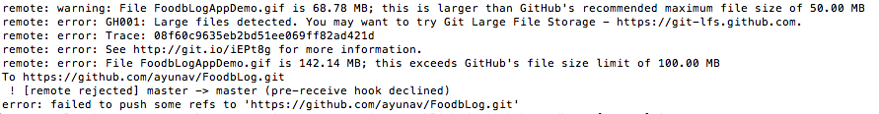

The most frustrating thing was that: 1) because the file was so big, and 2) because I didn’t know what I was doing, every push commit I was trying to make took soooooo long! I even timed it. 😩

https://miro.medium.com/max/60/1*uBst4Duuyq07B2iNz4SnRg.png?q=20

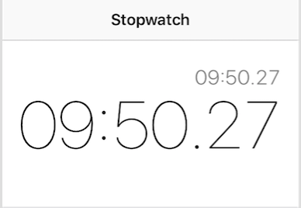

**So how do we push large files like audios, videos, datasets, and graphics to GitHub?**

Here’s what I did. (I hope my learning experience helps other developers who bump into the same issue).

1. Follow directions in your push commit error and go to [git-lfs.github.com](https://git-lfs.github.com/). Download Git extension for versioning large files (Git LFS) or install it via Homebrew. [Instructions](https://git-lfs.github.com/). **NB**: **Remove** your large file from your local repo directory **BEFORE** you set tracking for Git LFS.
2. Here’s the tricky part: you probably already added and removed your large file a couple of times and tried to push to GitHub. I certainly did. Now, your/my commits still have that large file data tracked locally that hasn’t been pushed.
3. You may need to squash your commits or [checkout](https://www.atlassian.com/git/tutorials/undoing-changes/) changes, but this is the hack I came up with: when you remove your large file from your local repo, reset to a commit that was right BEFORE you added the file.
4. git log and git reset commands will help get back to that commit.  
   Example:

https://miro.medium.com/max/60/1*TqqrwJ--nzUjDdAM1Y6Vzw.png?q=20

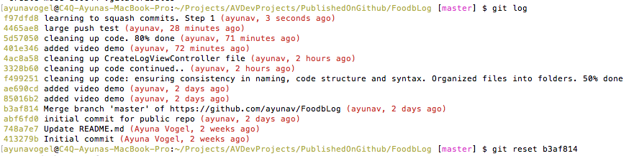

5. Set up Git LFS tracking for the type of files you want to add to your repo. [Instructions](https://git-lfs.github.com/). Example:

git lfs track "\*.psd" // for photoshop files  
git lfs track "\*.gif" // for gif video files

6. Add the file to your repo. LFS will now start tracking it and thus allow the push commit. Then add, commit, and push as usual. Example:

git add FoodbLogAppDemo.gif  
git commit -m "Add video demo"   
git push origin master

Note: after the data is finished uploading, you might see the same error (the file is too large) in your terminal. Check your repo on GitHub’s website and refresh the browser. Your file should be uploaded, despite the error message.

So, once again:

**FIRST**add git lfs track, **THEN** add a large file (like audio, etc.) to your repo.

Check out the FoodbLog app on GitHub: [github.com/ayunav/FoodbLog](https://github.com/ayunav/FoodbLog)

Also, here’s the link to my favorite [Atlassian tutorial on Git workflows](https://www.atlassian.com/git/tutorials/comparing-workflows) for those who just shifted from individual to group projects.

There are several workflows you can follow when working on projects in groups of two or more people: you can use the same master branch, or work off different branches of the same repo, or work on different forks.

If you’re confused which pattern to follow, I highly recommend the Atlassian’s tutorial above. It helped me to become a better developer and a better team contributor. And remember, everything comes with practice!!

I’m going to include the search keywords that I used to research this problem, which may be helpful for people with the same issue: github pre-receive hook declined, github squash commits, git push large files, git outside repository.

Resources: [Git Large File Storage (LFS)](https://git-lfs.github.com/), [Can’t push to github (pre-receive hook declined)](https://github.com/github/git-lfs/issues/434), [Issues with pushing large files through GIT](http://stackoverflow.com/questions/19858590/issues-with-pushing-large-files-through-git), [GitHub Help: Working with large files](https://help.github.com/enterprise/11.10.340/user/articles/working-with-large-files/) (read this if you added and removed your large file from your repo multiple times), [squashing commits with rebase](http://gitready.com/advanced/2009/02/10/squashing-commits-with-rebase.html), [How to rebase a pull request](https://github.com/edx/edx-platform/wiki/How-to-Rebase-a-Pull-Request).

https://miro.medium.com/max/34/1*_3zlqxobOoTRJ-EalWDcZw.png?q=20